Micro Service

creating Eureka Server project using spring initializer

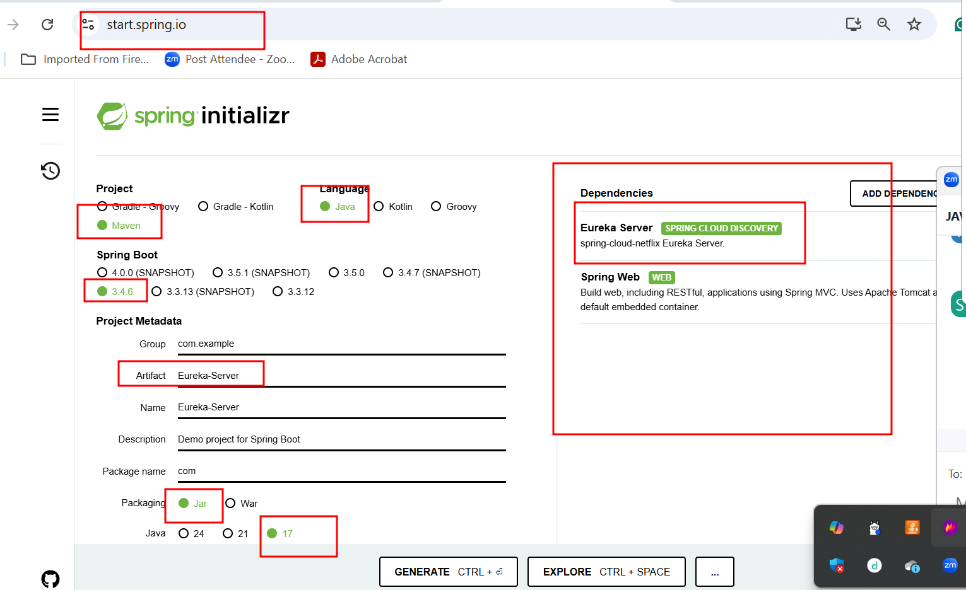

By default eureka server port number is 8761

Creating first simple micro service project

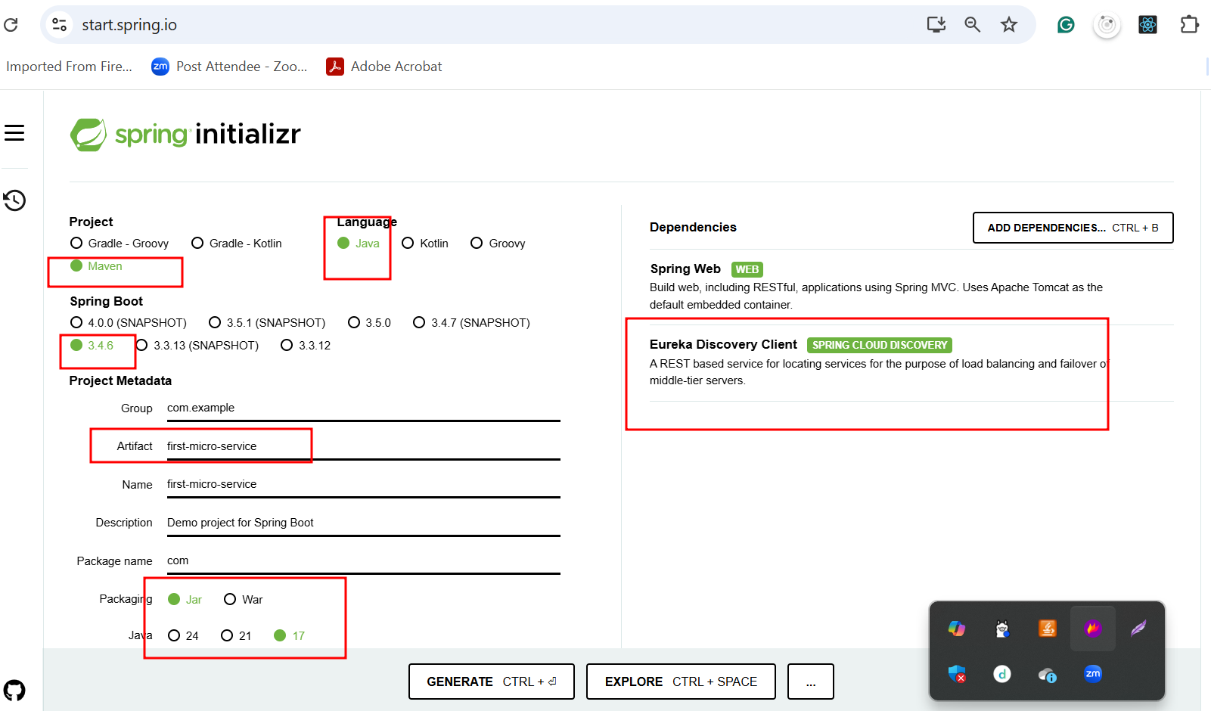

Creating second simple micro service project

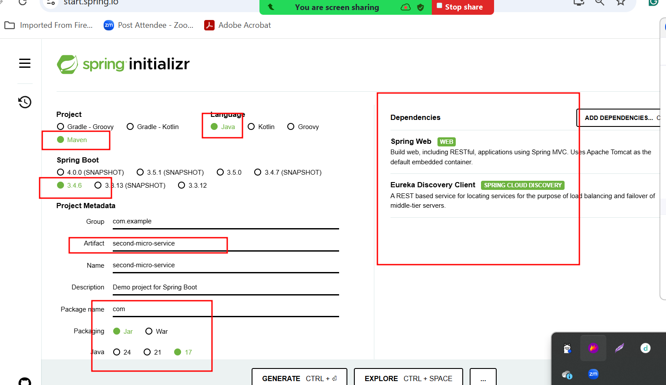

3rd micro service project as account micro service
- Create account -- Rest End Point using post
- FindBalance -- Rest End Point using get method passing as account id
- Find Account number - rest End point using get method passing emailid as unique key.

Starter - Web starter
Starter - JPA starter
Dependency - mysql connector
Starter - dev tools (whenever we do any changes in project automatically refresh the project).
Starter - Eureka discovery client
Port number 8282

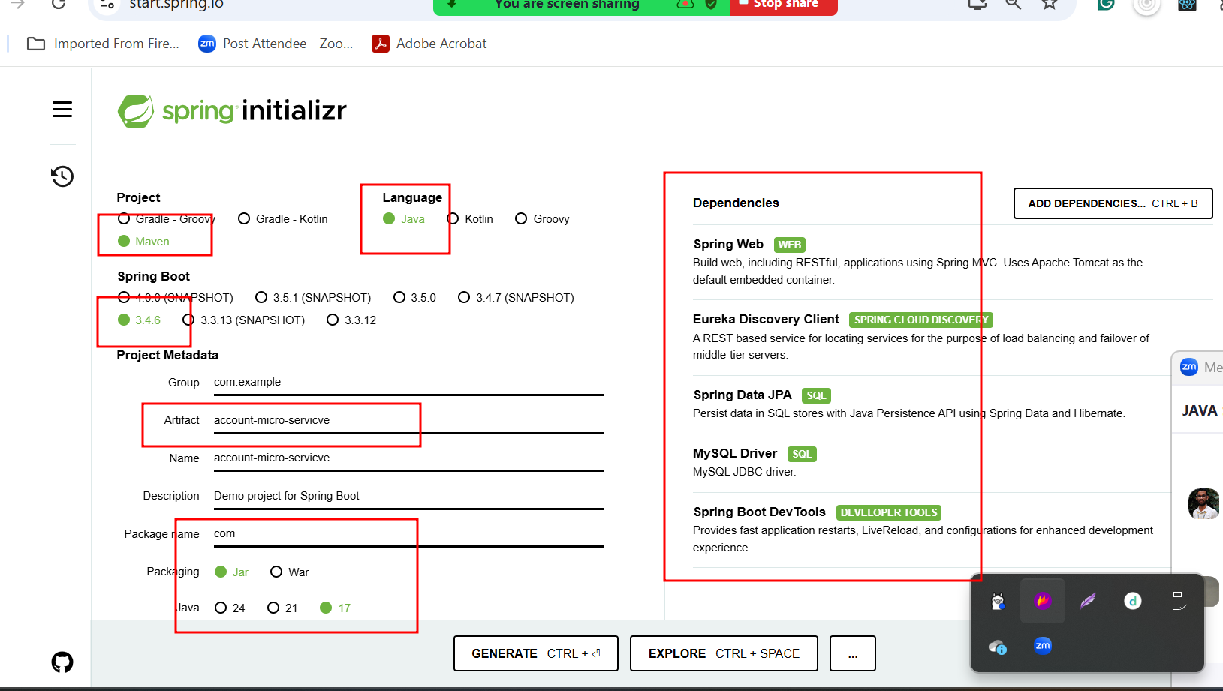

@RequestMapping annotation we can use on class level as well as method level.
Method level is use to map the path as well as request method like get, post ,put and delete.
Class level to provide root path.

